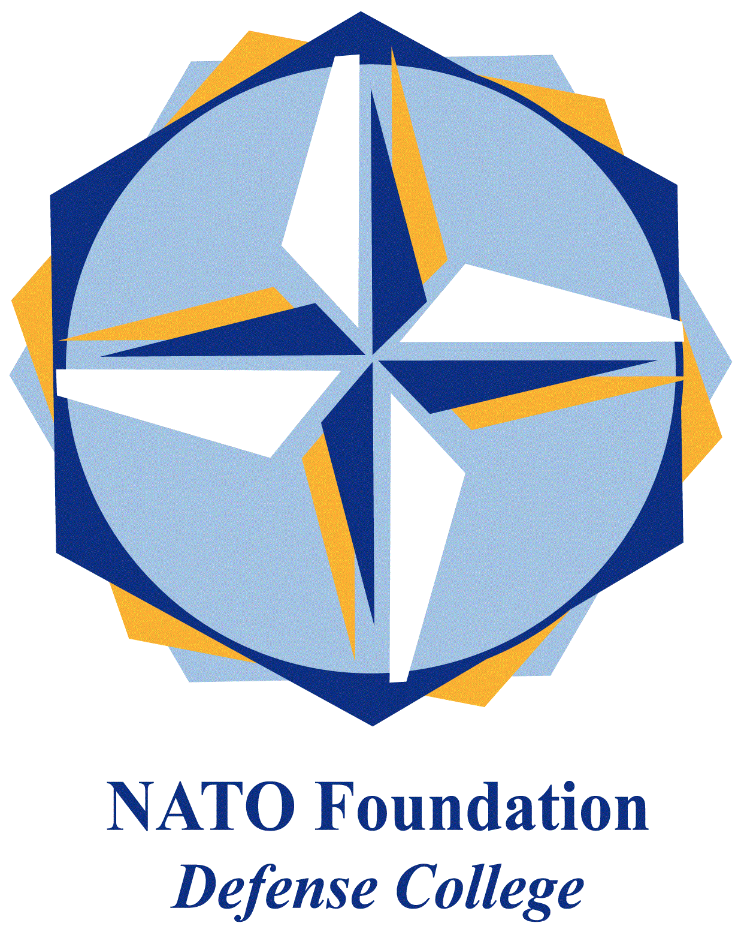
NATO DEFENSE COLLEGE FOUNDATION
STRATEGIC TRENDS
July 2015
GULF
After the Nuclear Deal: Reshaping Gulf Security

The signature of the Iranian nuclear deal between Teheran and the 5+1 modifies the balance of power within the Gulf, potentially marking a new season for regional security. Differently from Israel, Gulf monarchies are not so concerned with the “Iranian bomb”, but they feel more threatened by the geopolitical and oil consequences of the nuclear agreement. From 2016 on, the progressive lift of international sanctions will give to Teheran more economic power than before, which could be also used to finance political movements and militias across the Middle East, especially in proxy confrontation areas such as Syria and Yemen.
Therefore, after the deal, the unavoidable step for international community is to reshape the Gulf security architecture as soon as possible, to minimize risks of further militarisation and nuclear proliferation facilitated by Gulf Cooperation Council’s monarchies, maximizing instead positive-sum solutions for both shores of the Gulf. The Gulf - since Saudi Arabia and Iran have been fighting their Middle Eastern Cold War, under the mask of sectarianism - is the pivot of a broad regional (in)security complex, from North Africa to the Levant to AFPAK. For this reason, Gulf’s rivalries affect the whole region and need to be tackled with the tools of politics.
GCC monarchies have already been attempting to diversify their international alliances, although in the framework of the necessary partnership with the United States. Now, the trend will probably become even more evident. In this sense, Asia is the new horizon, where oil politics have paved the way for foreign policy alliances with China, South Korea, Indonesia and India: the real “pivot to Asia” has been done by the GCC. Saudi deputy crown prince and defence minister, Mohammad bin Salman, has just visited Russia, signing a nuclear cooperation agreement. From the perspective of energy security, Saudi Arabia has been developing its own nuclear programme (as United Arab Emirates are doing at a faster pace); but in order to counterbalance Iran soon, the kingdom could acquire nuclear warheads from its ally Pakistan. It is rather established the role of Saudi Arabia in supporting the creation of the Pakistani deterrent.
Nevertheless, Asian powers and Russia cannot (and do not want to) replace the United States as external security guarantors of the Gulf monarchies, also because they now want to do business with Teheran too. It is not by chance that, for instance, the brand new BRICS-led Asian Infrastructure Investment Bank (AIIB) encompasses GCC states (with the exception of Bahrain, which has just regained access to US arms transfer after a four year-ban) and Iran.
Even though Riyadh and Abu Dhabi are the mainstays of the GCC, it will be interesting to observe how the other monarchies will concretely behave towards Teheran. Qatar and Oman share gas interests with Iran (Sultan Qaboos’ mediation was vital to start the American-Iranian détente in 2013), while the commercial-oriented Dubai hosts a significant Iranian diaspora. In the meantime, the Saudi king seems to push for the strengthening of the Sunni axis against Teheran: Saudi leadership met Khaled Meshaal, leader of HAMAS, during the Umrah pilgrimage in Mecca (a pilgrimage less important than the annual Hajj), while Saudi-Qatari-Turkish backed militias are coordinating their operations in Syria.
Notwithstanding some official declarations wishing for Saudi-Iranian dialogue (as the Iranian and the Omani foreign ministers recently did), there is still little room for diplomatic de-escalation between Riyadh and Teheran, or for trilateral talks brokered by Washington. If the support for the fragile Iraqi government could be a convergent interest (now that the self-proclaimed caliphate has also hit in Arabia), multi-layered conflicts in Syria and Yemen contribute to feed the intra-Gulf divide. In fact, on September 2014 Saudi and Iranian foreign ministers met in New York to discuss how to face terrorism, but few days later Yemeni Houthis (supported by Teheran) seized Sana’a; as usual Gulf’s relations worsened.
Thus, the United States could enhance their commitment for the GCC defence, not focusing on a legally-binding formal security agreement (which should also require the Congress’ approval), but upgrading their political engagement into the US-GCC Strategic Cooperation Forum, as mentioned in the Joint Statement released after the last Camp David summit. The areas of enhanced cooperation should be arms transfer, military to military activities, anti-missile defence, cyber and maritime security. Moreover, the Annex to the Joint Statement makes reference to the creation of a US-GCC senior working group on rapid response capabilities, taking also into account the Arab League’s project of a “unified Arab force” for counterterrorism and peacekeeping, sponsored by Saudi Arabia and the United Arab Emirates. While Washington provides security guarantees to the GCC, these need to be corroborated by NATO’s professionalization efforts: the Istanbul Cooperation Initiative (ICI) could be redrawn to address the focal issue of interoperability, consolidating not only the membership of small states, but getting also Saudi Arabia and Oman to enter the ICI.
Thus, in such regional scenario (with an eye to Israel’s military superiority), the only way to prepare the ground for hypothetical, futures talks between the two rivers of the Gulf seems, before, to enlarge the “Gulf security pie”.

